Group symbol: 3
Team: 1

Project title: Resource Allocation App

Team members (filled by PM, Team Leader):
No | Name | Surname | Student ID | Role
1 | Carmelo Aidan | Romero | 293936 | PM, Team Leader
2 | Álvaro | Puebla | 293867 | Team member
3 | David | Sosa | 293885 | Team member
4 | Diego | Ceballos | 293943 | Team member
5 | Diego | García | 293939 | Team member
6 | Óscar | López | 293871 | Team member

- Requirements specification (S2)
  - Functional Requirements Specification
In this section, provide the table for functional requirements, including symbol, type (e.g. business logic, user interface, data exchange, etc.) description, significance (MoSCoW) and source (Stakeholder).
The core functional requirements for the 6-week MVP center on unified resource booking, checkout, and physical verification. Users (students, faculty, staff) must be able to discover and reserve any campus resource (books, rooms, equipment, etc.) with a clear UI, then check out/check in items by scanning QR/barcodes, with status updates visible in real time. Notifications (email/push) must alert users on confirmations, due dates and overdue items. Basic admin interfaces allow library staff to manage inventory and loans. Post-MVP requirements expand on analytics, advanced policy and approval workflows, and reporting as summarized below:

MVP Functional Requirements: core features (Must = critical, Should/Could = less critical)
Symbol | Type | Description | Significance | Source
FR1 | User Interface / Search | Search Resources: allow users to search, filter and browse resources (books, rooms, equipment) by type, location and availability. | Must | Students / Researcher
FR2 | Business Logic | Reservation Creation: Enable users to create and modify reservations for resources over specified time windows. | Must | Students / Researcher
FR3 | UI / Data View | View Availability Map: display current availability/location of resources on a map or dashboard, reflecting recent check-ins/check-outs. | Must | Students / Researcher
FR4 | UI / Integration | Scan QR: support camera-based scanning of QR/barcodes on resources to initiate the appropriate workflow (checkout or return). | Must | Students / Researcher
FR5 | Business Logic | Check Out Resource: when scanning or following reservation confirmation, create an active loan record and mark resource as on-loan. | Must | Students / Researcher
FR6 | Business Logic | Return Resource: when scanning a returned item or via a return flow, close the loan record and mark resource available. | Must | Students / Researcher
FR7 | Business Logic / Scheduling | Schedule Recurring Reservation: allow creation of repeating reservations (e.g., weekly lab slot). | Should | Researcher

  - Non-Functional Requirements
In this section provide the table for non-functional requirements that includes symbol, type (e.g., efficiency, standards, constraints, etc.), description, significance (MoSCoW) for the project, source (Stakeholder). Each requirement should also have specified a verification method – a description of a confirmation method whether a requirement has been fulfilled or not in the most measurable and objective way.
Key non-functional requirements derive from the project’s technological, legal and organizational context. These include security (campus SSO, encryption), performance and scalability, accessibility and audit compliance, and deployment constraints. Metrics and verification methods are specified to ensure measurable quality.

Symbol | Type | Description | Significance | Source | Verification Method
NF1 | Compatibility / Device Support | QR Scanning Support — mobile browsers must support camera-based QR/barcode scanning (no native app required). | Must | Student; Researcher | Test scanning flow on representative mobile browsers/devices (Android Chrome, iOS Safari) and report pass/fail matrix.
NF2 | Performance / Responsiveness | Availability Map Freshness — updates to availability after a check-in/check-out must be reflected in the map/dashboard within 2 seconds under nominal conditions. | Must | Student; Researcher | Instrument functional test: perform check-in/out and measure time until UI reflects the change; repeat 50 times and report median/p95 latencies.
NF3 | Performance | Search Responsiveness — typical search/filter operations should return results with median response <500 ms under expected single-user conditions. | Should | Student; Researcher | Execute automated search performance tests and report median and p95 response times.
NF4 | Accessibility / Standards | Basic Accessibility — core search/reservation/scan flows must be keyboard operable and readable by common screen readers (WCAG basics). | Should | Student; Researcher | Manual verification with a screen reader and keyboard-only navigation for the primary flows; record issues and pass/fail.

  - Use Case Diagram
You should prepare the use case diagram in UML 2.5 depicting the roles of stakeholders who are users of the project. It should also present the high-level concept of system usage divided into modules. Use case diagram should not cover common business logic (e.g. registration and logging in, CRUD operations).
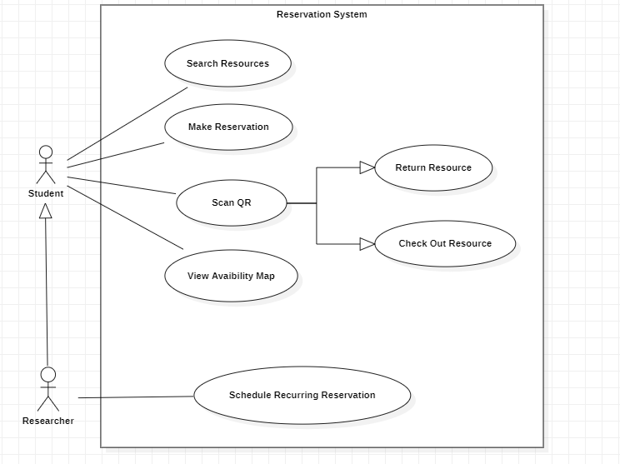
Actors include Student and Faculty/Researcher. The system uses cases focus on reservation and loan workflows and physical check-in/out.

